Experiment 1: Data Loading, Cleaning, and Preprocessing

Aim:
The goal of this experiment is to understand how to load a dataset, clean it, and perform basic preprocessing steps to prepare it for analysis.

1. Importing Required Libraries
import pandas as pd
import numpy as np
import matplotlib.pyplot as plt
from sklearn.preprocessing import MinMaxScaler
Explanation:
- pandas: For handling data in tabular format.
- numpy: For numerical computations.
matplotlib.pyplot: For data visualization.
- MinMaxScaler: For normalizing data.

2. Loading the Dataset
data = pd.read_csv('covid19_data.csv')
Explanation: We use pd.read_csv() to load the COVID-19 dataset into a DataFrame.

3. Understanding the Data
print(data.describe())
print(data.info())
Explanation:
- describe(): Provides a statistical summary of the dataset, including mean, median, min, and max values.
- info(): Displays metadata such as column names, data types, and non-null counts.

4. Displaying the First Few Rows
print(data.head())
Explanation: head(): Displays the first five rows of the dataset to provide an overview of its structure and content.
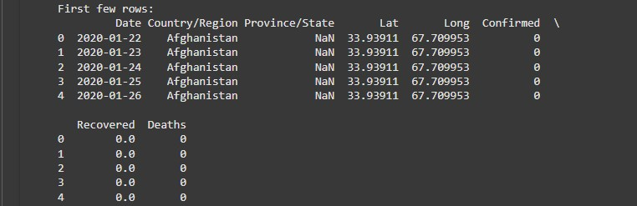

5. Visualizing Outliers with Box Plot
plt.figure(figsize=(10, 8))
plt.boxplot(data['Confirmed'], vert=False)
plt.title('Box Plot of Confirmed COVID-19 Cases')
plt.xlabel('Confirmed Cases')
plt.show()
Explanation: A box plot helps visualize the distribution of confirmed cases, detecting outliers and understanding the spread of the data.

6. Checking for Missing Values
print(data.isnull().sum())
data.fillna(method='ffill', inplace=True)
Explanation:
- isnull().sum(): Displays the number of missing values in each column.
- fillna(method='ffill'): Fills missing values using forward fill to maintain time series consistency.

7. Visualizing the Distribution of Confirmed Cases with Histogram
plt.figure(figsize=(8, 6))
plt.hist(data['Confirmed'], bins=20, color='blue', edgecolor='black')
plt.title('Distribution of Confirmed COVID-19 Cases')
plt.xlabel('Confirmed Cases')
plt.ylabel('Frequency')
plt.grid(True)
plt.show()
Explanation: A histogram shows the frequency distribution of confirmed cases, providing insight into common ranges of case counts.

8. Handling Outliers Using the IQR Method
def handle_outliers(df, column):
Q1 = df[column].quantile(0.25)
Q3 = df[column].quantile(0.75)
IQR = Q3 - Q1
lower_bound = Q1 - 1.5 * IQR
upper_bound = Q3 + 1.5 * IQR
return np.clip(df[column], lower_bound, upper_bound)

for col in ['Confirmed', 'Deaths', 'Recovered']:
data[col] = handle_outliers(data, col)
Explanation: The interquartile range (IQR) method removes extreme outliers to improve data quality.

9. Normalizing Data
scaler = MinMaxScaler()
data[['Confirmed', 'Deaths', 'Recovered']] = scaler.fit_transform(data[['Confirmed', 'Deaths', 'Recovered']])
Explanation: Normalization scales numerical data to a range between 0 and 1, improving consistency for analysis.

10. Visualizing Trends Over Time
data['Date'] = pd.to_datetime(data['Date'])
plt.figure(figsize=(12, 6))
plt.plot(data['Date'], data['Confirmed'], label='Confirmed Cases', color='blue')
plt.plot(data['Date'], data['Deaths'], label='Deaths', color='red')
plt.title('COVID-19 Trends Over Time')
plt.xlabel('Date')
plt.ylabel('Normalized Values')
plt.legend()
plt.show()
Explanation: A line plot visualizes normalized trends of confirmed cases and deaths over time.

11. Saving the Cleaned Data
data.to_csv('cleaned_covid19_data.csv', index=False)
print("Cleaned data saved to 'cleaned_covid19_data.csv'.")
Explanation: The cleaned and preprocessed data is saved as a CSV file for further use.
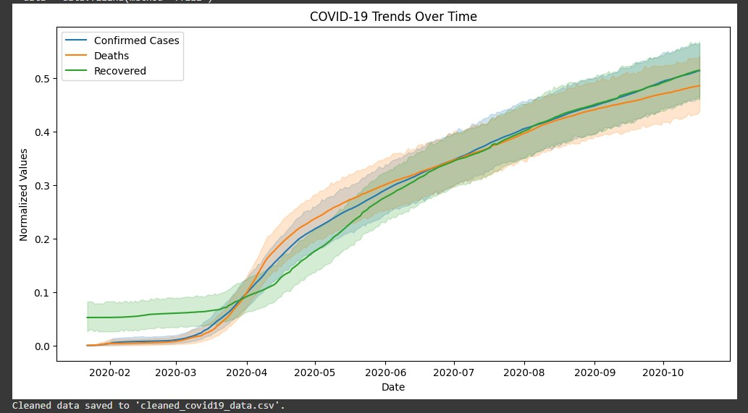

Result:

Thus, the COVID-19 dataset has been loading , cleaning it, and perform basic preprocessing has been completed successfully.

